**Assignment 4**

**1a) Basic sequential Clustering**

theta value is 12, maximum number of clusters as 4

Taking dataset in the given order. We observed 4 clusters as shown in the following diagram.

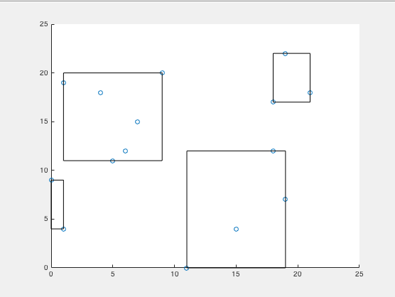

**1b) using the data points in the reverse order**

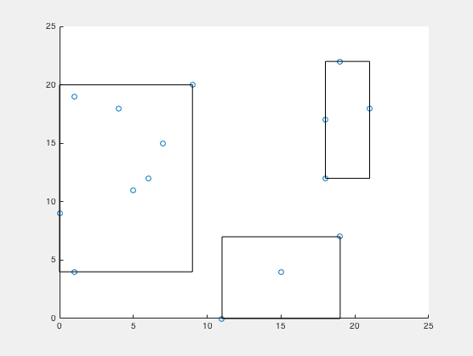

only 3 clusters are formed when we take data points in the reverse order.

**1c) Rand Index**

**Rand index to find the difference between the two clusterings:**

**ans =**

**0.6800**

In BSAS(Basic sequential algorithm scheme), each cluster is represented by a single vector. Which are said to be global clustering criteria. Here is the mean vector represents the cluster. Calculation of mean differs when ordering is changed. The order in which the vectors are presented to the BSAS plays an important role.

2a). Hierarchical clustering using single-link

Dendrogram

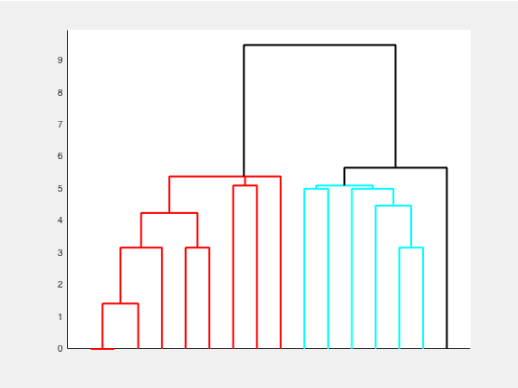

Clusters 2D plot

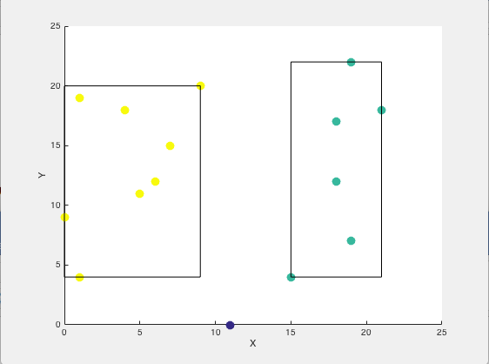

2b) Hierarchical clustering using complete link

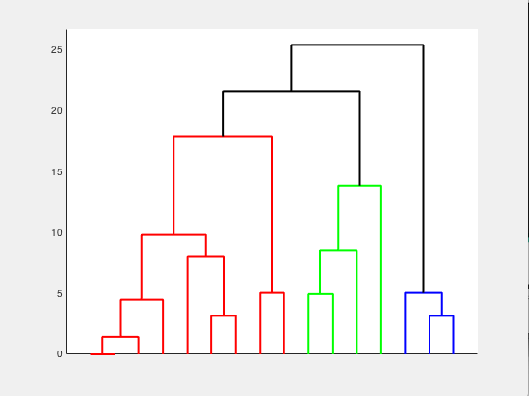

Clusters 2D plot using complete link

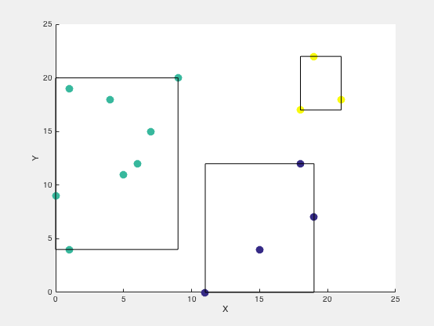

2c) the sum of squared errors for the clusterings obtained in (a) and (b)

sum of squared errors of Hierarchical Cluster using Single Link

SSE_SingleLink = 80.9975

**Cluster 3** is contributing more for the SSE

sum of squared errors of Hierarchical Cluster using Complete Link

SSE_CompleteLink = 72.4479

**Cluster 2** is contributing more for the SSE

2d)

Correlation for single link

correlation coefficient 7.259384e-01

Correlation for complete link

correlation coefficient 7.600997e-01

Correlation for complete link is higher than the single link

correlation between the proximity martix and binary martix for single link 7.269757e-01

correlation between the proximity martix and binary martix complete link 6.901631e-01

single link uses minimal distance between cluster points and other point to decide whether to merge in the cluster. Shortest Euclidian distance measure gives the high correlation among the cluster points.

3a) Use DBSCAN algorithm epsilon value is 4 and MinPoints value of 3

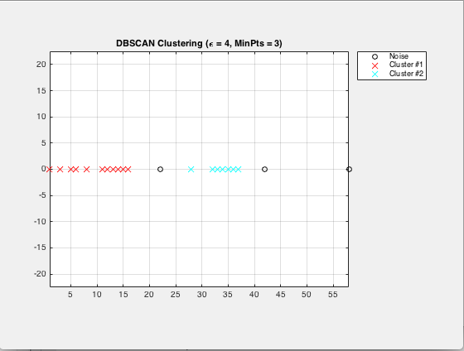

3b) Do the same as in (a) above but use Epsilon value of 6.

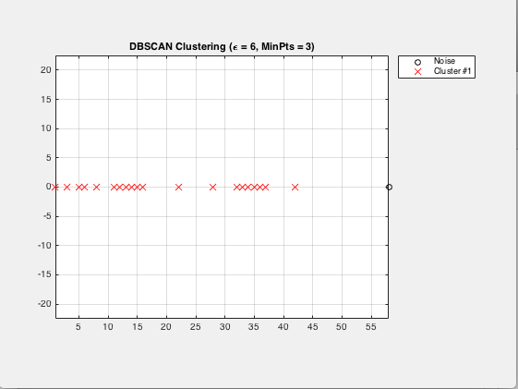

3c) Compare the two clustering’s using Rand Index and show all your work.

RandIndex =

0.4524

Density-based clustering uses local density of points to determine the clusters rather than using only the distance between points.

ε-*neighborhood* of **x**, too large, denser clusters may be merged together. ε-*neighborhood* of **x**, too small, sparse clusters will be categorized as noise.

**Source Code:**

**Main.m**

% [6, 12], [19, 7], [15, 4], [11, 0], [18, 12], [9, 20], [19, 22],

% [18, 17], [5, 11], [4, 18], [7, 15], [21, 18], [1, 19], [1, 4], [0, 9], [5, 11].

dsCell={[6, 12], [19, 7], [15, 4], [11, 0], [18, 12], [9, 20], [19, 22],[18, 17],...

[5, 11], [4, 18], [7, 15], [21, 18], [1, 19], [1, 4], [0, 9], [5, 11]};

%1a Basic Sequence Algorithm Scheme

m=1;

theta=12;

q=4;

obj=BasicSequentialAlgo(theta,q);

[Ck,Cm]=PartitionDatasetIntoClusters(obj,dsCell);

[bsSet]=plotClusters(Ck);

%1b Basic Sequence Algorithm Scheme the data points in the reverse order

[HCk,HCm]=PartitionDatasetIntoClusters(obj,fliplr(dsCell));

[hbsSet]=plotClusters(HCk);

%1c.Rand Index Calculation

N=nchoosek(length(dsCell),2);

a=0;

b=0;

c=0;

d=0;

for i=1:(length(dsCell)-1)

x1=dsCell{i};

for j=i+1:length(dsCell)

x2=dsCell{j};

samebsCluster=0;

samehbsCluster=0;

for rdinx=1:length(bsSet)

if((nnz(intersect(x1,bsSet{rdinx},'rows'))==2) && (nnz(intersect(x2,bsSet{rdinx},'rows'))==2))

samebsCluster=1;

break;

end

end

for dinx=1:length(hbsSet)

if((nnz(intersect(x1,hbsSet{dinx},'rows'))==2) && (nnz(intersect(x2,hbsSet{dinx},'rows'))==2))

samehbsCluster=1;

break;

end

end

if(samebsCluster==1 && samehbsCluster==1)

a=a+1;

elseif(samebsCluster==0 && samehbsCluster==0)

b=b+1;

elseif(samebsCluster==1 && samehbsCluster==0)

c=c+1;

elseif(samebsCluster==0 && samehbsCluster==1)

d=d+1;

else

end

end

end

fprintf('Rand index to find the difference between the two clusterings:\n')

(a+b)/N

X=[6 12; 19 7; 15 4; 11 0; 18 12; 9 20; 19 22;18 17;

5 11; 4 18; 7 15; 21 18; 1 19; 1 4; 0 9; 5 11];

NUM=3;%No. of Clusters

PairDistance = pdist(X);

% 2a. Hierarichal clustering using single link

singleLink = linkage(PairDistance,'single');

singleLinkClusterData = clusterdata(X,'linkage','single','maxclust',NUM);

figure();

singleLinkDendogram = dendrogram(singleLink, 0, 'colorthreshold',mean(singleLink(end-NUM+1:end-NUM+2,3)));

set(singleLinkDendogram,'LineWidth',2)

set(gca, 'XTickLabel',[], 'TickLength',[0 0])

singleLinkClustPtsCell={};

% dividing points into clusters

for idxClust=1:NUM

singleLinkClustPtsCell(idxClust)={X(find(singleLinkClusterData==idxClust),:)};

end

figure();

scatter(X(:,1),X(:,2),100, singleLinkClusterData, 'filled')

xlabel X, ylabel Y

hold on

for rectId=1:length(singleLinkClustPtsCell)

rectangle('Position', [min(singleLinkClustPtsCell{rectId}(:,1)) min(singleLinkClustPtsCell{rectId}(:,2))...

max(singleLinkClustPtsCell{rectId}(:,1))-min(singleLinkClustPtsCell{rectId}(:,1))...

max(singleLinkClustPtsCell{rectId}(:,2))-min(singleLinkClustPtsCell{rectId}(:,2))]);

end

% 2b. Hierarichal clustering using complete link

completeLink = linkage(PairDistance,'complete');

completeLinkClusterData = clusterdata(X,'linkage','complete','maxclust',NUM);

figure();

completeLinkDendogram = dendrogram(completeLink, 0, 'colorthreshold',mean(completeLink(end-NUM+1:end-NUM+2,3)));

set(completeLinkDendogram,'LineWidth',2)

set(gca, 'XTickLabel',[], 'TickLength',[0 0])

completeLinkClustPtsCell={};

% dividing points into clusters

for idxClust=1:NUM

completeLinkClustPtsCell(idxClust)={X(find(completeLinkClusterData==idxClust),:)};

end

figure();

scatter(X(:,1),X(:,2),100, completeLinkClusterData, 'filled')

xlabel X, ylabel Y

hold on

for rectId=1:length(completeLinkClustPtsCell)

rectangle('Position', [min(completeLinkClustPtsCell{rectId}(:,1)) min(completeLinkClustPtsCell{rectId}(:,2))...

max(completeLinkClustPtsCell{rectId}(:,1))-min(completeLinkClustPtsCell{rectId}(:,1))...

max(completeLinkClustPtsCell{rectId}(:,2))-min(completeLinkClustPtsCell{rectId}(:,2))]);

end

%2c Calculating Sum of squared errors

fprintf('sum of squared errors of Hierarchical Cluster using Single Link');

SSE_SingleLink=sumofSquaredErrors(singleLinkClustPtsCell)

fprintf('sum of squared errors of Hierarchical Cluster using Complete Link')

SSE_CompleteLink=sumofSquaredErrors(completeLinkClustPtsCell)

%2d.Use the correlation analysis to determine which of these two

% clusterings (obtained in (a) and (b)) has higher correlation

% Compute Spearman's rank correlation between the

% dissimilarities and the cophenetic distances

fprintf('\nCorrelation for single link \n');

[Cophenetic_Cor_SingleLink,D] = cophenet(singleLink,PairDistance);

r1 = corr(PairDistance',D','type','spearman');

fprintf('Cophenetic correlation coefficient %d\n',Cophenetic_Cor_SingleLink);

fprintf('\nCorrelation for complete link \n');

[Cophenetic_Cor_CompleteLink,D] = cophenet(completeLink,PairDistance);

r2 = corr(PairDistance',D','type','spearman');

fprintf('Cophenetic correlation coefficient %d\n',Cophenetic_Cor_CompleteLink);

% correlation between the proximity martix and binary martix

fprintf('correlation between the proximity martix and binary martix for single link %d\n',r1);

fprintf('correlation between the proximity martix and binary martix complete link %d\n',r2);

%3a). DBSCAN algorithm

Xi=[1, 3, 5, 6, 8, 11, 12, 13, 14, 15, 16, 22, 28, 32, 33, 34, 35, 36, 37, 42, 58];

Xi=Xi';

Yi=repmat(0,1,21);

Yi=Yi';

Res=[Xi Yi];

epsilon=4;

MinPts=3;

IDX1=dbscan(Res,epsilon,MinPts);

figure();

PlotClusterinResult(Res, IDX1);

title(['DBSCAN Clustering (\epsilon = ' num2str(epsilon) ', MinPts = ' num2str(MinPts) ')']);

%3b.Do the same as in (a) above but use Epsilon value of 6.

epsilon=6;

MinPts=3;

IDX=dbscan(Res,epsilon,MinPts);

figure();

PlotClusterinResult(Res, IDX);

title(['DBSCAN Clustering (\epsilon = ' num2str(epsilon) ', MinPts = ' num2str(MinPts) ')']);

%3c)Compare the two clusterings using Rand Index and show all your work.

a=0;

b=0;

for indx=1:length(IDX1)-1

x1=IDX1(indx);

y1=IDX(indx);

for jndx=indx+1:length(IDX)

x2=IDX1(jndx);

y2=IDX(jndx);

if((x1==x2) && (y1==y2))

a=a+1;

elseif((x1~=x2) && (y1~=y2))

b=b+1;

end

end

end

N1=nchoosek(length(IDX1),2);

RandIndex=(a+b)/N1

**BasicSequentialAlgo.m**

classdef BasicSequentialAlgo

properties

theta=[]; % threshold value

q=[]; % maximum number of clusters constriant

dataset={}; % dataset cell

Cm={}; % dataset contains clusters means

Ck={}; % dataset contains clusters points

m=0;

end

methods

% Input: threshold value and maximum no. of clusters

% Output: returns the BSAS obj

function self=BasicSequentialAlgo(theta,q)

self.m=1;

self.theta=theta;

self.q=q;

self.Cm={};

self.Ck={};

end

% Input: threshold value and maximum no. of clusters

% Output: returns the BSAS obj

function [Ck,Cm] = PartitionDatasetIntoClusters(self,ds)

self.dataset=ds;

self.Cm(self.m)=self.dataset(1);

self.Ck{self.m}=self.dataset(1);

for i=2:length(self.dataset)

[distance,index]=findMinDistancetoMean(self,self.dataset(i),self.Cm);

% if(size(self.Ck,2)>=index)

% self.Ck{self.m}=[self.Ck{index},self.Cm(index)];

%

% else

% self.Ck(index)= {self.Cm(index)};

% end

%

if((distance>self.theta) && (self.m<self.q))

self.m=self.m+1;

self.Cm(self.m)=self.dataset(i);

self.Ck{self.m}=self.dataset(i);

else

if(size(self.Ck,2)>=self.m)

self.Ck{index}=[self.Ck{index},self.dataset(i)];

else

self.Ck(index)={self.dataset{i}};

end

%Find mean values of Clusters and change the mean of

%Clusters

for indx=1:length(self.Ck)

meanSet=self.Ck{indx};

x=0,y=0;

for subidx=1:length(meanSet)

x=x+meanSet{subidx}(1);

y=y+meanSet{subidx}(2);

end

newMean=[x/length(meanSet) y/length(meanSet)];

self.Cm(indx)={newMean};

end

end

end

Ck=self.Ck;

Cm=self.Cm;

end

% Input: instance vector and means set of clusters

% Output: returns minimum distance and its index value

function [distance,index]=findMinDistancetoMean(self,Xi,Cm)

for j=1:self.m

curMean=Cm(j);

distances(1,j)=sqrt((curMean{1}(1,1)-Xi{1}(1,1))^2+ (curMean{1}(1,2)-Xi{1}(1,2))^2);

end

[distance,index]=min(distances);

end

end

end

**plotClusters.m**

function[newSets]=plotClusters(Ck)

newSets={};

X=[],Y=[];

for idx=1:length(Ck)

subSet=Ck{idx};

x=[];

y=[];

for sidx=1:length(subSet)

x(length(x)+1,1)=subSet{sidx}(1);

y(length(y)+1,1)=subSet{sidx}(2);

end

newSets{idx}=[x y];

X=vertcat(X,x);

Y=vertcat(Y,y);

end

figure();

scatter(X,Y);

hold on

for rectId=1:length(newSets)

rectangle('Position', [min(newSets{rectId}(:,1)) min(newSets{rectId}(:,2))...

max(newSets{rectId}(:,1))-min(newSets{rectId}(:,1)) max(newSets{rectId}(:,2))-min(newSets{rectId}(:,2))]);

end

end

**PlotClusterinResult.m**

function PlotClusterinResult(X, IDX)

k=max(IDX);

Colors=hsv(k);

Legends = {};

for i=0:k

Xi=X(IDX==i,:);

if i~=0

Style = 'x';

MarkerSize = 8;

Color = Colors(i,:);

Legends{end+1} = ['Cluster #' num2str(i)];

else

Style = 'o';

MarkerSize = 6;

Color = [0 0 0];

if ~isempty(Xi)

Legends{end+1} = 'Noise';

end

end

if ~isempty(Xi)

plot(Xi(:,1),Xi(:,2),Style,'MarkerSize',MarkerSize,'Color',Color);

end

hold on;

end

hold off;

axis equal;

grid on;

legend(Legends);

legend('Location', 'NorthEastOutside');

end

**sumofSquaredErrors.m**

function [SSE]=sumofSquaredErrors(singleLinkClustPtsCell)

arrSSE=[];

for indx=1:length(singleLinkClustPtsCell)

meanSet=singleLinkClustPtsCell{indx};

newMean=[sum(meanSet(:,1))/size(meanSet,1) sum(meanSet(:,2))/size(meanSet,1)];

meanDist=0;

for subidx=1:size(meanSet,1)

distn=sqrt((meanSet(subidx,1)-newMean(1,1))^2+ (meanSet(subidx,2)-newMean(1,2))^2);

meanDist=meanDist+distn;

end

arrSSE(1,indx)=meanDist;

end

SSE=sum(arrSSE);

end

Dbscan.m

function [IDX, isnoise]=dbscan(X,epsilon,MinPts)

C=0;

n=size(X,1);

IDX=zeros(n,1);

D=pdist2(X,X);

visited=false(n,1);

isnoise=false(n,1);

for i=1:n

if ~visited(i)

visited(i)=true;

Neighbors=RegionQuery(i);

if numel(Neighbors)<MinPts

% X(i,:) is NOISE

isnoise(i)=true;

else

C=C+1;

ExpandCluster(i,Neighbors,C);

end

end

end

function ExpandCluster(i,Neighbors,C)

IDX(i)=C;

k = 1;

while true

j = Neighbors(k);

if ~visited(j)

visited(j)=true;

Neighbors2=RegionQuery(j);

if numel(Neighbors2)>=MinPts

Neighbors=[Neighbors Neighbors2]; %#ok

end

end

if IDX(j)==0

IDX(j)=C;

end

k = k + 1;

if k > numel(Neighbors)

break;

end

end

end

function Neighbors=RegionQuery(i)

Neighbors=find(D(i,:)<=epsilon);

end

end